**VIEWS AND EVENTS**

**CREATION OF TABLES**

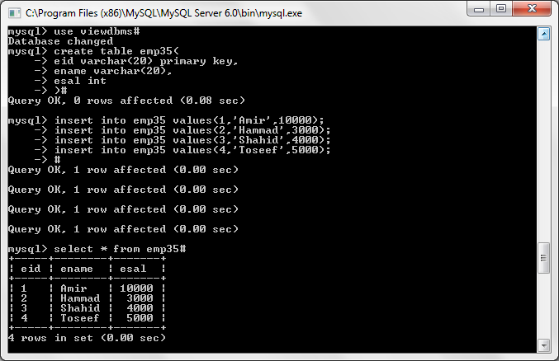

**VIEW**

create view view35(vename,vesal) as

select ename,esal from emp35#

select * from view35#

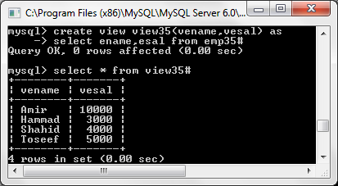

**EVENT**

create event event35

on schedule every 3 second

do update emp35 set esal=esal+200#

